BIOBRIEF

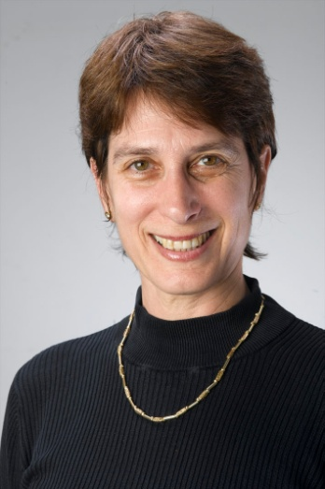
Anat Treister-Goren, Ph.D.,
International Coach Federation (ICF) accredited:

Master Certified Coach (MCC)
Certified Professional Co-Active Coach (CPCC)
Organizational Relationship System Coach Certified (ORSCC)

Dr. Anat Treister-Goren is the Owner of
Lead, Out of the Box Leadership, Ltd.

Anat offers various coaching services including executive coaching, team- coaching, facilitation of coach-training programs, designing organizational coaching processes, and more. As an Executive Coach, she works with hi-potentials, senior executives and leaders, mid-level managers, women in leadership positions, business owners, partnerships, teams and more. She leads training workshops focused on coach-approach to management, relationship and system leading skills, collaborative and individual leadership development, and trainings for teams and team leaders.

Anat serves as an international facilitator, coach, and supervisor with world leading schools and programs:

The Coaches Training Institute, US, Europe, Middle East
The Center for Right Relationship, US, Europe, Middle and Far East
Team Coaching International
Ken Blanchard

The models taught in all of these schools are based on latest findings in the fields of Emotional and Social Intelligences, Appreciative Inquiry, Positive Psychology, Change integration and management, System Work, Deep Democracy, Co-Active Coaching, Process Psychology, Situational Leadership, and more.

Anat has extensive experience in coaching senior executives in world leading organizations such as Intel, Cap-Gemini, Micron, Shire Pharmacy company, Banks, Investment houses, leading fashion companies, and more. She works with executives from all over the world via the phone, Skype and face to face. Her coaching processes take place anywhere between 6 month to over a year and topics and agenda typically evolve as aims are accomplished, and new ones discovered. Anat also works with small groups globally, either in virtual environments or face to face. Anat is well experienced with the feedback and development process associated with individual 360 assessments.

Anat’s has worked for the past seven years with an extensive number of corporate clients from diverse fields including banks, venture capitals, and investment firms, hi-tech companies such as start-ups and mid to large corporations, retail and food industries, security services, cloth industries, branding, educational institutes and more. She has coached senior managers and leaders from counties such as Spain, UK, Holland, Denmark, Germany, Sweden, Norway, and France, Switzerland, Japan, US, Israel and more.

Background:
In her past careers, Dr. Treister-Goren has been a lecturer and researcher in areas of Schizophrenic thought disorder, Linguistics and Conversational Analysis, Speech Pathology, Brain and Language, in major universities in the US and Israel for over ten years. She had also worked for several years as a senior executive in hi-tech companies focused on speech recognition and artificial intelligence, in business development, R&D, and marketing positions. In her more distant past she was a professional singer and actress. Thus, she is well rounded in both managerial and leadership aspects as well as in emotional and social intelligence competencies and skills. Her coaching and facilitation services combine her expertese from all careers and her high credentials and education in the coaching and leadership domain.

Academic degrees:
Ph.D. University of Washington, Neurolinguistics/Speech-Language Pathology, 1991.
M.Sc. University of Washington, Speech Science, 1989.
B.A. U of California Davis, Theoretical Linguistics, 1985.
Coach training education:
Organizational Relationship System Coach Certified (ORSCC), The Center for Right Relationship, USA., December 2008 (ICF accredited school)
Certified Professional Co-Active Coach (CPCC), the Coaches Training Institute, USA, 2006, (ICF accredited school)
Master Certified Coach, ICF accredited.
Team Training Intensive Certification, Team Training International, USA, 2006. (ICF accredited)
Co-Active Leadership program, The Coaches Training Institute, USA, 2006.
Certified Personal and Business Coach, Telem College, Israel, 2004.

